*Fundamentals of Programming in C++ (CoSc 2031)**Project work for CS Year II Students* *** ***

**Faculty of Informatics**

**HAWASSA UNIVERSITY**

**Institute of Technology**

**DEPARTMENT Computer Science**

**Fundamentals of Programming in c++ project work**

*Project Title: Grade reporting system for HU-IoT, FoI, Department of CS, IS and IT students*

|  |  |  |
| --- | --- | --- |
|  | | |
| *No* | ***Name*** | *Id Number* |
| *1* | **Degaga Emiru** | **NaScR/0413/15** |

*Contents*

*1. Introduction: 3*

*2. Problems of the project (Statement of the problem): 3*

*3. Objectives 3*

*3.1. General Objectives: 3*

*3.2. Specific Objectives: 3*

*4. Precise description of the existing system: 4*

*5. Materials and Methods: 4*

*6. Scope: 6*

*7. The C++ implementation: 6*

*8. Results (Discussions): 20*

*Reference: 26*

# Introduction:

*This Grade Reporting System is designed in C++ programming language by using devC++ complier and it is used to calculate the grade of students for the three departments (IS, IT, CS) of the Faculty of Informatics of Hawassa University. It contains eleven(11) functions such that six(6) of them perform the registration, modification and deletion of either students Information or course Information. Five structures are stated in so that 3 of them hold the different courses each department is giving, one the department choice and the other holds member variables to store personal information.*

*The program maintains the records of students by using file operations. The Grade Reporting System deals with student details, course details, course grades and other related details. The System is helpful for students, teachers as well as the department registrar. Our Grade Reporting System deals with the various activities related to the Grade of students.*

*There are mainly 3 divisions in this project:*

* *The students*
* *The teacher*
* *The registrar*

*This implies the users can be of three types which are mentioned above. The Registrar is able to add new student and can edit and delete students registered information. Students are allowed to see their full recorded information including their marks of each course they take in the Semester, the Credit Hours of each course, the grades they got on every course, and their GPA of the Semester. The Teacher can add, edit and delete the course results of each student. All the users must provide correct password before entering into the system. File handling has been efficiently used to perform all these operations.*

# Problems of the project (Statement of the problem):

This project is aimed to show students grade reports for the three departments and is based on a concept to generate student’s report in grading system.

# Objectives

## 3.1. General Objectives:

* *To develop a program that calculates the grade of students which contains up to date information of the students and that allows registering, updating and deleting tasks.*
* *To create a c++ program that can store, retrieve, display, insert and modify a student’s marks and calculate their respective grade.*

## 3.2. Specific Objectives:

* *To manage the evaluations and results of students*
* *To show the information and evaluation of Informatics students*
* *To add, edit and erase records which improves efficiency*
* *To integrate all the course and other personal information of the students*
* *To manage the grades data*

# Precise description of the existing system:

*In this system we keep a number of records related to the student and the details of the students and marks are manually entered. Only the teacher and the college registrar can enter and edit data which is also done manually.*

*An advantage of this system is that it is secure and easy to edit and delete a student when found unnecessary. The students can view their marks and grades by just entering their id number want as well which makes easy for them .*

*Our program collects student details like name, roll number, marks in each subject, and calculates their grade. We focus only on the correct inputs in this project, and you can improve it to handle wrong inputs.*

# Materials and Methods:

*In this system, first the user is given three login options which are: student login, teacher login and registrar login. Each of them require distinct login password for the user to get access.*

1. *The student login opens up the students main menu in which the user is only given two options, the first one is the grade report option and the other is the exit option which simply terminates the program. In the case the student chooses the grade report, it immediately asks for the student’s Id Number and if correct Id Number is provided or if the Id Number has been registered, the program displays all necessary information recorded under that Id Number including:*

* *Personal and educational information of the student such as full name, age, sex, department, program and id number itself. These data are first recorded on the text File named* ***“stdInfoFile.txt”*** *by the registrar during registration of students through registrar login and are then read from this file into the text file called* ***“stdCourseFile.txt”*** *when the teacher registers course results of the student. They are kept in this file also in order to match the student’s course data with his\her personal information.*
* *The list of all the courses the student is taking in that semester with their corresponding credit hours. All registered students whether their department is Information System (IS), Information Technology (IT) or Computer Science (CS) take exactly seven courses.*

*The courses for IS are as follows:*

* 1. *Fundamentals of Programming in C++*
  2. *Introduction to Information Systems*
  3. *Fundamentals of Accounting*
  4. *Discrete Mathematics and Combinatory*
  5. *Economics*
  6. *Introduction to Statistics*
  7. *Inclusiveness*

*The courses which CS students are taking are the following:*

1. *Fundamentals of Programming in C++*
2. *Fundamentals of Database Systems*
3. *Economics*
4. *Abstract Algebra*
5. *Probability and Statistics*
6. *Global Trends*
7. *Inclusiveness*

*For IT the courses are:*

1. *Fundamentals of Programming in C++*
2. *Fundamentals of Database Systems*
3. *Global Trends*
4. *Computer Organization & Architecture*
5. *Fundamentals of Electricity*
6. *Probability and Statistics*
7. *Inclusiveness*

* *Then it shows the results of each course out of 100% for that particular student that has been recorded by the teacher in the student marks registration through teacher login.*
* *The grades are displayed for each subject after calculating them based on the results provided.*
* *Grade points carried by each grade the student gets is also shown following the grades.*

*The grades and grade points are given as shown in the table below:*

|  |  |  |  |  |  |  |  |  |
| --- | --- | --- | --- | --- | --- | --- | --- | --- |
| *Grade* | *Point* | *Mark* | *Grade* | *Point* | *Mark* | *Grade* | *Point* | *Mark* |
| *A+* | *4* | *90 -100* | *B* | *3* | *70 - 75* | *C-* | *1.75* | *50 - 55* |
| *A* | *4* | *85 - 90* | *B-* | *2.75* | *65 - 70* | *D* | *1* | *40 - 50* |
| *A-* | *3.75* | *80 - 85* | *C+* | *2.5* | *60 - 65* | *F* | *0* | *0 - 40* |
| *B+* | *3.5* | *75 - 80* | *C* | *2* | *55 - 60* |  |  |  |

* *Total grade point is then printed out for each course after being calculated by multiplying the grade points of each course with their corresponding credit hours.*
* *Finally the student is shown his/her GPA of the Semester. It is calculated by dividing the Sum of every course’s total grade points by the total credit hour of the Semester.*

1. *The teacher login opens up the Teacher Main Menu in which the teacher is given four options which allow the registration, modification and removal of the student’s course results.* 
   1. *Course Results Registration: This operation opens the function “****void courseResult();”*** *in which the file “stdInfoFile.txt” is opened and each student’s basic information as Department, Program, Name, Id Number, Age and Sex is read and stored in variables. These details have been recorded by the registrar into the file* ***“stdInfoFile.txt”****.**Then it creates new text file called “stdCourseInfo.txt” or open it if the file is created already in order to write results of the student on it. The teacher is required to enter Id Number of the student he\she wants to record marks for and the id number is used to search whether the student has been registered or not. If Id Number exists the program lets the teacher to insert results out of 100% for every course the student is taking which is different based on to the department as discussed above (in 1. student Login). It stores all the marks as well as the recovered personal information together in the “stdCourseInfo.txt” file after integrating them together.*
   2. *Course Marks Modification: “****void updateResult();”*** *function is used to edit the marks documented in “stdCourseInfo.txt” file. The details are first recorded during 1st option (results registration). This operation just reads those details and allows the teacher to document new marks.*
   3. *Course File and Marks Deletion: This selection opens “* ***void deleteResult();”*** *where this function further offers two additional options. The delete course file option completely erases the file* ***“stdCourseInfo.txt”*** *with all records inside of it. The second option however lists all the course marks lets the teacher clear individual course marks from the existing file. This function also requires the student’s Id Number to search him\her among the registered students. The fourth choice is just the exit option.*
2. *The Registrar Login unlocks the registrar main menu in which the user is further provided with 4 options. The options are implemented by using file operations. They are: Registration, Modification, Deletion and Exit. All the options except for the exit option after being chosen lead to different function where the operations are applied.*

* *The first option (Registration) opens the* ***“void studentInfo();”*** *function in which a text file* ***“stdInfoFile”*** *is created or opened for modification if it already exists and the students personal data is stored line by line. The function and the text file together allow us to register as many students as possible and this stored information is later read by other functions to perform other tasks.*
* *The second option (Updating) opens the* ***“void updateStudInfo();”*** *function that reads the students data, stores them in variables, and then changes the strings stored in those varibles whenever the registrar enters new values and finally writes all the data on a new file* ***“newUpdated”*** *. The program then closes both files, removes the* ***“stdInfoFile”*** *file from which all the information is read and renames the* ***“newUpdated”*** *file back to* ***“stdInfoFile”***
* *The third option (Deletion) opens the “void deleteStudInfo()”. This function works exactly like the update function except it deletes the data it reads instead of modifying them. In addtion to deleting personal information of the student one by one the registrar can also delete the “stdInfoFile” itself.*

# Scope:

*This project “Grade report system” covers the information of the students, the 3 departments, course records and other various activities. This project is designed with C++ language, which provides all features as functions, file operations, structures looping statement, and others. Our current system has numerous functions such as registration, student records, student performance, and so on.*

*This overall project is basically written in function. We have provided many data function through which any one can know about any registered students giving student id number.*

# The C++ implementation:

*1: #include<iostream>  
2: #include<fstream>  
3: #include<string.h>  
4: #include<cstdlib>  
5: #include<string>  
6:* ***using namespace std;****7:  
8:* ***void studentInfo(); void updateStudInfo(); void deleteStudInfo();****9:* ***void courseResult(); void updateResult(); void deleteResult();****10:  
11:* ***void depttChoice(); void gradeReport();****12:* ***void studentLogin(); void teacherLogin(); void registrarLogin();****13:  
14:* ***struct dept { char dpt[30]; };****15:* ***struct isCourses****16:* ***{****17:* ***float cpp, acc, math, eco, is, stat, incl;****18:* ***};****19:* ***struct itCourses****20:* ***{****21:* ***float cpp, db, coa, elic, gt, stat, incl;****22:* ***};****23:* ***struct csCourses****24:* ***{****25:* ***float cpp, db, alg, eco, gt, stat, incl;****26:* ***};****27:* ***struct student{****28:* ***char prog[30]; char idno[10];****29:* ***char age[3]; char f_name[25];****30:* ***char l_name[25]; char sex[10];****31:* ***struct isCourses s; struct itCourses t;****32:* ***struct csCourses c; struct dept d1;****33:* ***};****34:  
35:* ***int main (){****36:* ***system("color 5B");****37:* ***int choice, deptChoice; string tpassword, spassword, rpassword;****38:* ***outerloop:****39:* ***system("cls");****40:* ***cout<<"\t\t\t\t HAWASSA UNIVERSITY"<<endl;****41:* ***cout<<"\t\t\t\t INSTITUTE OF TECHNOLOGY"<<endl;****42:* ***cout<<"\t\t\t\t FACULTY OF INFORMATICS"<<endl;****43:****cout<<"==============================================================================="<<endl;****44:* ***cout<<" \t\t\t\tStudent Grade Reporting System"<<endl;****45:****cout<<"================================================================================"<<endl;****46:* ***cout<<"\n\t\t 1. STUDNET LOGIN"<< "\t 2. TEACHER LOGIN" << "\t 3. REGISTRAR LOGIN"<<endl;****47:* ***cout<<"\n\t\t :"; cin>>choice;****48:  
49:* ***switch(choice){****50:  
51:* ***case 1: retry1: system("cls");****52:* ***cout<<"\n\n\tENTER PASSWORD: "; cin>>spassword;****53:* ***if(spassword=="123") { studentLogin();}****54:* ***else {cout<<"\n\tINVALID PASSWORD. Please Try Again...";****55:* ***goto retry1; } break;****56:* ***case 2: retry2: system("cls");****57:* ***cout<<"\n\n\tENTER PASSWORD: "; cin>>tpassword;****58:* ***if(tpassword=="456") { teacherLogin(); }****59:* ***else {cout<<"\n\tINVALID PASSWORD. Please Try Again...";****60:* ***goto retry2; } break;****61:* ***case 3: retry3: system("cls");****62:* ***cout<<"\n\n\tENTER PASSWORD: "; cin>>rpassword;****63:* ***if(rpassword=="789") {registrarLogin(); }****64:* ***else {cout<<"\n\tINVALID PASSWORD. Please Try Again...";****65:* ***goto retry3; } break;****66:  
67:* ***default: system("cls"); cout<<" \n\n\tINVALID CHOICE, PLEASE TRY AGIAN "<<endl; break;****68:* ***}****69:* ***char ny;****70:****cout<<"\n\tDo you want to Return to the Main Menu? Press 'y' for Yes or 'n' for No : ";cin>>ny;****71:* ***if(ny ==****'y'****|| ny ==****'Y'****) { goto outerloop;}****72:* ***else exit(0);****73:  
74:* ***return 0;****75:* ***}****76:  
77:* ***void depttChoice()****78:* ***{****79:* ***struct dept d1; ofstream studDeptFile;****80:* ***studDeptFile.open("studDeptFile.txt",ios::out);****81:* ***int deptChoice;****82:* ***cout<<"*******************CHOOSE DEPARTMENT******************"<<endl;****83:* ***cout<<"------------------------------------------------------"<<endl;****84:* ***cout<<"\n 1.Information System"<<endl;****85:* ***cout<<"\n 2.Information Technology"<<endl;****86:* ***cout<<"\n 3.Computer Science"<<endl;****87:* ***cout<<" :";cin>>deptChoice;****88:* ***char dtChoice [40];****89:* ***switch(deptChoice)****90:* ***{****91:* ***case 1: system("cls"); strcpy (d1.dpt, "Information_System"); cout<<endl;****92:* ***cout<<"\t**************************************************"<<endl;****93:* ***cout<<"\t\tDEPARTMENT OF INFORMATION SYSTEM"<<endl;****94:* ***cout<<"\t**************************************************"<<endl;****95:* ***break;****96:* ***case 2: system("cls"); strcpy (d1.dpt, "Information_Technology"); cout<<endl;****97:* ***cout<<"\t*****************************************************"<<endl;****98:* ***cout<<"\t\tDEPARTMENT OF INFORMATION TECHNOLOGY"<<endl;****99:* ***cout<<"\t****************************************************"<<endl;****100:* ***break;****101:* ***case 3: system("cls"); strcpy (d1.dpt, "Computer_Science"); cout<<endl;****102:* ***cout<<"\t*************************************************"<<endl;****103:* ***cout<<"\t\tDEPARTMENT OF COMPUTER SCIENCE"<<endl;****104:* ***cout<<"\t*************************************************"<<endl;****105:* ***break;****106:* ***default: system("cls"); cout<<"Invalid Choice";****107:* ***}****108:* ***studDeptFile <<d1.dpt<<endl; studDeptFile.close();****109:* ***}****110:  
111:  
112:  
113:* ***void studentLogin(){****114:* ***loops: system("cls");****115:* ***int choice;****116:* ***cout<<"\n\t\t1. Display Grade Report"<<endl;****117:* ***cout<<"\n\t\t2. Exit"<<endl; cout<<"\t\t :";cin>> choice;****118:  
119:* ***switch(choice){****120:* ***case 1: system("cls"); gradeReport(); break;****121:* ***case 2: exit(0); break;****122:* ***default: cout<<" \n\n\tINVALID CHOICE, PLEASE TRY AGIAN "<<endl;****123:* ***goto loops;****124:* ***}****125:* ***char yn;****126:* ***cout<<"\n\tReturn to the STUDENT MENU? Press 'y' for Yes or 'n' for No: ";cin>>yn;****127:* ***if(yn ==****'y'****|| yn ==****'Y'****) { goto loops;} else exit(0);****128:* ***}****129:  
130:  
131:  
132:* ***void teacherLogin(){****133:* ***loopt: system("cls");****134:* ***int choice;*** *135:* ***cout<<"\n\n\t\tPlease Choose from the following Options"<<endl;****136:* ***cout<<"\n\t\t1.Register Students Course Results"<<endl; cout<<"\n\t\t2.Update Students Course***

***Results"<<endl;****137:* ***cout<<"\n\t\t3.Delete Students Course Results"<<endl; cout<<"\n\t\t4.Exit"<<endl;***

*138:* ***cout<<"\t\t:";cin>>choice;****139:* ***switch(choice){****140:* ***case 1: system("cls"); courseResult(); break;****141:* ***case 2: system("cls"); updateResult(); break;****142:* ***case 3: system("cls"); deleteResult(); break;****143:* ***case 4: system("cls"); exit(0); break;****144:* ***default: cout<<" \n\n\tINVALID CHOICE, PLEASE TRY AGIAN "<<endl;****145:* ***goto loopt;}****146:  
147:* ***char yn;****148:* ***cout<<"\n\tReturn to the TEACHER MENU? Press 'y' for Yes or 'n' for No : "; cin>>yn;****149:* ***if(yn ==****'y'****|| yn ==****'Y'****) { goto loopt;} else exit(0);****150:* ***}****151:  
152:  
153:  
154:* ***void registrarLogin(){****155:* ***int choice;****156:* ***loopr: system("cls");****157:* ***cout<<"\n\tPlease Choose from the following Options";****158:* ***cout<<"\n\t1.REGISTER Students"; cout<<"\n\t2.UPDATE Registered Students Information";****159:* ***cout<<"\n\t3.DELETE Registered Students Information"; cout<<"\n\t4.Exit"<<endl;***

*160:* ***cout<<"\t\t:";cin>> choice;****161:* ***switch(choice){****162:* ***case 1: system("cls"); depttChoice(); studentInfo(); break;****163:* ***case 2: system("cls"); updateStudInfo(); break;****164:* ***case 3: system("cls"); deleteStudInfo(); break;****165:* ***case 4: exit(0); break;****166:* ***default:cout<<" \n\n\tINVALID CHOICE, PLEASE TRY AGIAN "<<endl;****167:* ***goto loopr; }****168:  
169:* ***char ny;****170:* ***cout<<"\n\tDo You Want to Return to the REGISTRAR MENU? Press 'y' for Yes or 'n' for No : ";***

***cin>>ny;****171:* ***if(ny ==****'y'****|| ny ==****'Y'****) { goto loopr;} else exit(0);****172:* ***}****173:  
174:  
175:  
176:* ***void studentInfo()****177:* ***{****178:* ***struct dept d1;****179:* ***string dept,prog ,id, f_name, l_name , age , sex;****180:* ***char dpt[40];****181:* ***ofstream stdInfoFile; ifstream studDeptFile;****182:  
183:* ***stdInfoFile.open("stdInfoFile.txt", ios::out|ios::app);****184:* ***studDeptFile.open("studDeptFile.txt",ios::in);****185:  
186:* ***studDeptFile.getline(dpt,40); //to copy the line in the (studDeptFile.txt) file to the****187:* ***//arry that has beeb chosen in the (deptChoice) function****188:* ***cout<<"\n\t\t======================================================";****189:* ***cout<<"\n\t\t--------------STUDENTS INFORMATION MENU---------------"<<endl;****190:* ***int n;****191:* ***cout<<"\n For how many students do you want to enter data:"<<endl;****192:* ***cout<<"\t\t:";cin>>n;****193:  
194:* ***student studArr [n]; // an array of type students called studArr****195:* ***cout<<"\t_-_-_-_-_-_-_-_-_-_STUDENT DETAILS_-_-_-_-_-_-_-_-_-_"<<endl;****196:  
197:* ***for(int i=0;i<n;i++) {****198:  
199:* ***cout<<"\n\t\tDetails for Student: "<<i+1;****200:  
201:* ***cout<<"\n\tEnter Student "<<i+1<<" PROGRAM:"; cin>>studArr[i].prog;*** *202:  
203:* ***cout<<"\n\tEnter Student "<<i+1<<" ID NUMBER:"; cin>> studArr[i].idno;****204:  
205:* ***cout<<"\n\tEnter Student "<<i+1<<" FIRST NAME:"; cin>>studArr[i].f_name;****206:  
207:* ***cout<<"\n\tEnter Student "<<i+1<<" LAST NAME:"; cin>>studArr[i].l_name;****208:  
209:* ***cout<<"\n\tEnter Student " <<i+1<<" AGE:"; cin>>studArr[i].age;****210:  
211:* ***cout<<"\n\tEnter Student " <<i+1<<" SEX:"; cin>>studArr[i].sex; cout<<endl;****212:  
213:* ***stdInfoFile <<dpt<<" " <<studArr[i].prog<<" " <<studArr[i].idno<<" " <<studArr[i].f_name<<" "****214:* ***<<studArr[i].l_name<<" " <<studArr[i].age<<" " <<studArr[i].sex<<" "<<endl;****215:* ***}****216:* ***stdInfoFile.close();****217:* ***}****218:  
219:  
220:  
221:* ***void courseResult()****222:* ***{****223:* ***int n, count=0;****224:* ***cout<<"\n\tFor how many students do you want to enter course marks?"<<endl;****225:* ***cout<<" :";cin>>n;****226:* ***crLoop:****227:* ***struct isCourses s; struct itCourses t; struct csCourses c;****228:* ***string srch, idno,dept, prog, age, sex, f_name ,l_name;****229:  
230:* ***ofstream outFile; ifstream inFile;****231:* ***inFile.open("stdInfoFile.txt"); outFile.open("stdCourseFile.txt", ios::out|ios::app);****232:* ***if(!inFile.is_open()) {cout<<"File Not Found"<<endl; exit(1);}****233:  
234:* ***cout<<"\n\tEnter the Id Number of the Student you want to record marks for:"<<endl;****235:* ***cout<<"\t\t:"; cin>>srch;****236:  
237:* ***while(inFile>>dept>>prog >>idno >> f_name>> l_name >> age >> sex){****238:* ***if(srch==idno){****239:* ***cout<<"-_-_-_-_-_-_-_-_-_-_-_-_-_-_-_-_-_-_-_-_-_-_-_-_-_-_-_-_-_-_-_-_-_-_-_-_-_-_"<<endl;****240:* ***cout<<"\n\tDepartment: "<<dept; cout<<"\tFull Name: "<<f_name <<" "<<l_name<<endl;****241:* ***cout<<"\n\tProgram: "<<prog<<"\tID Number: "<<idno<<"\tAge: "<<age<<"\tSex:"<<sex<<endl;****242:* ***cout<<"-_-_-_-_-_-_-_-_-_-_-_-_-_-_-_-_-_-_-_-_-_-_-_-_-_-_-_-_-_-_-_-_-_-_-_-_-_-_-"<<endl;****243:  
244:* ***cout<<"\n\tEnter "<<f_name <<" "<<l_name<<"'s " <<" marks to corresponding courses:\n";****245:  
246:* ***label1:****247:* ***if (dept=="Information_System") {cout<<"\n\t Fundamentals of Programming in c++ result:  
 ";cin>>s.cpp; if(s.cpp<0||s.cpp>100){****248:* ***cout<<"\n\tINVALID MARK, The mark range must be (0-100). Try agian!"<<endl; goto label1;}}***

*249:* ***else if (dept=="Information_Technology") {cout<<"\n\t Fundamentals of Programming in  
 c++ result: ";cin>>t.cpp; if(t.cpp<0||t.cpp>100){****250:* ***cout<<"\n\tINVALID MARK, The mark range must be (0-100). Try agian!"<<endl; goto  
 label1;}}***

*251:* ***else if (dept=="Computer_Science") {cout<<"\n\t Fundamentals of Programming in  
 c++ result: ";cin>>c.cpp; if(c.cpp<0||c.cpp>100){****252:* ***cout<<"\n\tINVALID MARK, The mark range must be (0-100). Try  
 agian!"<<endl; goto label1;}}****253:*

*254:* ***label2:****255:* ***if (dept=="Information_System") {cout<<"\n\t Accounting result: "; cin>>s.acc;****256:* ***if(s.acc<0||s.acc>100) {cout<<"\n\t INVALID MARK, The mark range must be (0-100). Try  
 agian!"<<endl;goto label2;} }****257:*

*258:* ***else if(dept=="Information_Technology") {cout<<"\n\t Database Systems result: "; cin>>t.db;****259:* ***if(t.db<0||t.db>100) {cout<<"\n\t INVALID MARK, The mark range must be (0-100). Try  
 agian!"<<endl; goto label2;} }*** *260:*

*261:* ***else if(dept=="Computer_Science") {cout<<"\n\t Database Systems result: ";  
 cin>>c.db;****262:* ***if(c.db<0||c.db>100) {cout<<"\n\t INVALID MARK, The mark range must be (0-100).  
 Try agian!"<<endl; goto label2;} }****263:*

*264:* ***label3:****265:  
266:* ***if (dept=="Information_System") { cout<<"\n\t Economics result: "; cin>>s.eco;  
 if(s.eco<0||s.eco>100){****267:* ***cout<<"\n\t INVALID MARK, The mark range must be (0-100). Try agian!"<<endl; goto label3;}}***

*268:* ***else if (dept=="Information_Technology") {cout<<"\n\t Computer Organization and Architecture  
 Result: "; cin>>t.coa;****269:* ***if(t.coa<0||t.coa>100) {cout<<"\n\tINVALID MARK, The mark range must be (0-100). Try  
 agian!"<<endl; goto label3;}}****270:*

*271:* ***else if(dept=="Computer_Science") {cout<<"\n\t Economics result: ";  
 cin>>c.eco; if(c.eco<0||c.eco>100){****272:* ***cout<<"\n\tINVALID MARK, The mark range must be (0-100). Try  
 agian!"<<endl; goto label3;}}****273:  
274:  
275:* ***label4:****276:* ***if (dept=="Information_System") {cout<<"\n\t Discrete Maths result: "; cin>>s.math;  
 if(s.math<0||s.math>100){****277:* ***cout<<"\n\t INVALID MARK, The mark range must be (0-100). Try agian!"<<endl; goto label4;}}****278:*

*279:* ***else if(dept=="Information_Technology") {cout<<"\n\t Fundamentals of Electricity result: ";  
 cin>>t.elic;****280:* ***if(t.elic<0||t.elic>100) {cout<<"\n\t INVALID MARK, The mark range must be (0-100). Try  
 agian!"<<endl; goto label4;} }****281:*

*282:* ***else if(dept=="Computer_Science") {cout<<"\n\t Abstract Algebra result: "; cin  
 >>c.alg; if(c.alg<0||c.alg>100)****283:* ***{cout<<"\n\t INVALID MARK, The mark range must be (0-100). Try agian!"<<endl; goto  
 label4;} }****284:*

*285:* ***label5:****286:* ***if (dept=="Information_System") { cout<<"\n\t Statistics result: ";cin>>s.stat;  
 if(s.stat<0||s.stat>100)****287:* ***{cout<<"\n\t INVALID MARK, The mark range must be (0-100). Try agian!"<<endl; goto label5;}}***

*288:* ***else if (dept=="Information_Technology") {cout<<"\n\t Statistics result: "; cin>>t.stat;  
 if(t.stat<0||t.stat>100){****289:* ***cout<<"\n\tINVALID MARK, The mark range must be (0-100). Try agian!"<<endl; goto  
 label5;}}***

*290:* ***else if (dept=="Computer_Science") { cout<<"\n\t Statistics result: ";  
 cin>>c.stat; if(c.stat<0||c.stat>100){****291:* ***cout<<"\n\tINVALID MARK, The mark range must be (0-100). Try  
 agian!"<<endl; goto label5;}}****292:*

*293:* ***label6:****294:* ***if (dept=="Information_System") {cout<<"\n\t Inclusiveness: "; cin>>s.incl;  
 if(s.incl<0||s.incl>100){****295:* ***cout<<"\n\t INVALID MARK, The mark range must be (0-100). Try agian!"<<endl;goto label6;}}***

*296:* ***else if (dept=="Information_Technology") {cout<<"\n\t Inclusiveness: "; cin>>t.incl;  
 if(t.incl<0||t.incl>100){****297:* ***cout<<"\n\tINVALID MARK, The mark range must be (0-100). Try agian!"<<endl; goto  
 label6;}}***

*298:* ***else if (dept=="Computer_Science") {cout<<"\n\t Inclusiveness: "; cin>>c.incl;  
 if(c.incl<0||c.incl>100){****299:* ***cout<<"\n\tINVALID MARK, The mark range must be (0-100). Try  
 agian!"<<endl; goto label6;}}****300:  
301:  
302:* ***label7:****303:* ***if (dept=="Information_System") {cout<<"\n\t Information Systems result: "; cin>>s.is;****304:* ***if(s.incl<0||s.incl>100){cout<<"\n\t INVALID MARK, The mark range must be (0-100). Try  
 agian!"<<endl; goto label7;}}*** *305:*

*306:* ***else if(dept=="Information_Technology") {cout<<"\n\t Global Trends result: "; cin>>t.gt;****307:* ***if(t.gt<0||t.gt>100) {cout<<"\n\t INVALID MARK, The mark range must be (0-100). Try  
 agian!"<<endl; goto label7;} }****308:*

*309:* ***else if(dept=="Computer_Science") {cout<<"\n\t Global Trends result: ";  
cin>>c.gt;****310:* ***if(c.gt<0||c.gt>100) {cout<<"\n\t INVALID MARK, The mark range must be (0-  
 100). Try agian!"<<endl; goto label7;} }****311:  
312:* ***if (dept=="Information_System") {outFile <<dept<<" " <<prog<<" " <<idno<<" " <<f_name<<" "  
 <<l_name<<" " <<age<<" " <<sex<<" "****313:* ***<<s.cpp<<" " <<s.acc<<" " <<s.eco<<" " <<s.math<<" " <<s.stat<<" "  
 <<s.incl<<" " <<s.is<<endl;}***

*314:* ***else if (dept=="Information_Technology") {outFile <<dept<<" " <<prog<<" " <<idno<<" " <<f_name<<" " <<l_name<<" " <<age<<" " <<sex<<" "***

*315:* ***<<t.cpp<<" " <<t.db<<" " <<t.coa<<" " <<t.elic<<" " <<t.gt<<" "  
 <<t.stat<<" " <<t.incl<<endl;}***

*316:* ***else if (dept=="Computer_Science") {outFile <<dept<<" " <<prog<<" " <<idno<<" " <<f_name<<" "  
 <<l_name<<" " <<age<<" " <<sex<<" "****317:* ***<<c.cpp<<" " <<c.db<<" " <<c.alg<<" " <<c.eco<<" " <<c.gt<<" "  
 <<c.stat<<" " <<c.incl<<endl;}****318:* ***}} count++; if (n>count){ goto crLoop;}****319:* ***outFile.close(); inFile.close();****320:* ***}****321:  
322:  
323:  
324:* ***void updateStudInfo()****325:* ***{****326:* ***int n;****327:* ***cout<<"\n\tFor how many students do you want to UPDATE Information?"<<endl;****328:* ***cout<<" :";cin>>n;****329:* ***int count=0;****330:* ***loopLabel:****331:* ***string srch;****332:* ***string dept, prog ,idno,age, sex,f_name ,l_name;****333:  
334:* ***ofstream outFile; ifstream inFile;****335:* ***outFile.open("newupdated.txt"); inFile.open("stdInfoFile.txt");****336:  
337:* ***if(!inFile.is_open()) {cout<<"File Not Found"<<endl;exit(1); }****338:  
339:* ***cout<<"\n\tEnterthe Id Number of the Student you want to update for."<<endl;****340:* ***cout<<"\t\t"; cin>>srch;****341:  
342:* ***while(inFile>>dept>>prog >>idno >> f_name>> l_name >>age>>sex){****343:* ***if(srch==idno) {****344:****cout<<"\n===================================================================================";****345:* ***cout<<"\tDEPARTMENT: "<<dept;cout <<"\t\tPROGRAM: "<<prog;cout <<"\tID NUMBER: "<<idno<<endl;****346:* ***cout<<"\tFULL NAME: "<<f_name<<" "<<l_name<< " \t\tSEX: " <<sex<< "\t\tAGE: "<<age <<endl;****347:****cout<<"\n===================================================================================";****348:* ***cout<<"\n\tEnter New Program:"; cin>>prog;****349:* ***cout<<"\n\tEnter New First Name:"; cin>>f_name;****350:* ***cout<<"\n\tEnter New Last Name:"; cin>>l_name;****351:* ***cout<<"\n\tUpdate sex to:"; cin>>sex;****352:* ***cout<<"\n\tEnter New Age:"; cin>>age;****353:* ***}****354:* ***outFile <<dept<<" " <<prog<<" " <<idno<<" " <<f_name <<" " <<l_name<<" " <<age <<" "  
 <<sex <<" " <<endl;****355:* ***}count ++;****356:* ***if(n>count){goto loopLabel;}****357:  
358:* ***inFile.close(); outFile.close();*** *359:* ***remove("stdInfoFile.txt"); rename("newupdated.txt","stdInfoFile.txt");****360:* ***}****361:  
362:  
363:  
364:  
365:* ***void updateResult()****366:* ***{****367:* ***int n;****368:* ***cout<<"\n\tFor how many students do you want to UPDATE course marks?"<<endl;****369:* ***cout<<"\t\t:";cin>>n;****370:* ***int count=0;****371:* ***urLoop:****372:* ***struct isCourses s; struct itCourses t; struct csCourses c;****373:* ***string srch,dpt,age,idno,prog,f_name,l_name,sex,mark1,mark2,mark3,mark4,mark5,mark6, mark7;****374:* ***float db, coa, elic, gt, cpp, acc, eco ,math ,stat ,incl ,is, alg;****375:* ***//FOR IS---mark1=cpp mark2=acc mark3=eco mark4=math mark5=stat mark6=incl mark7=is****376:* ***//FOR IT---mark1=cpp mark2=db mark3=coa mark4=elic mark5=gt mark6=stat mark7=incl****377:* ***//FOR CS---mark1=cpp mark2=db mark3=alg mark4=eco mark5=gt mark6=stat mark7=incl****378:* ***ofstream outFile; ifstream inFile;****379:* ***outFile.open("newupdated.txt",ios::out|ios::app); inFile.open("stdCourseFile.txt");****380:  
381:* ***if(!inFile.is_open()) {cout<<"File Not Found"<<endl; exit(1); }****382:  
383:* ***cout<<"\n\tEnter the ID NUMBER of the Student you want update Result for."<<endl;****384:* ***cout<<"\t\t"; cin>>srch;****385:  
386:* ***while(inFile>>dpt>>prog>>idno>>f_name>> l_name>> age>> sex>>mark1>>mark2>>mark3>>  
 mark4>>mark5>>mark6>>mark7){****387:* ***if(srch==idno ){****388:****cout<<"=========================================================================================";****389:* ***cout<<"\tDEPARTMENT: "<<dpt; cout <<"\t\tPROGRAM: "<<prog; cout <<"\tID NUMBER:***

***"<<idno<<endl;****390:* ***cout<<"\tFULL NAME: "<<f_name<<" "<<l_name; cout<< " \t\tSEX: " <<sex; cout<< "\t\tAGE:***

***"<<age <<endl;****391:****cout<<"====================================================================================";****392:  
393:* ***if(dpt=="Information_System"){****394:  
395:* ***cout<<"\n\tEnter New Fundamentals of Programming in c++ Mark:" ; cin>>mark1;****396:* ***cout<<"\n\tEnter New Accounting Mark:" ; cin>>mark2;****397:* ***cout<<"\n\tEnter New Economics Mark:" ; cin>>mark3;****398:* ***cout<<"\n\tEnter New Discrete Mathematics Mark:" ; cin>>mark4;****399:* ***cout<<"\n\tEnter New Statistics Mark:" ; cin>>mark5;****400:* ***cout<<"\n\tEnter New Inclusiveness Mark:" ; cin>>mark6;****401:* ***cout<<"\n\tEnter New Information Systems Mark:" ; cin>>mark7;****402:* ***}****403:* ***else if( dpt=="Information_Technology"){****404:* ***cout<<"\n\tEnter New Fundamentals of Programming in c++ Mark:" ; cin>>mark1;****405:* ***cout<<"\n\tEnter New Database Systems Mark:" ; cin>>mark2;****406:* ***cout<<"\n\tEnter New Computer Organization and Architecture Mark:" ; cin>>mark3;****407:* ***cout<<"\n\tEnter New Fundamentals of Electricity Mark:" ; cin>>mark4;****408:* ***cout<<"\n\tEnter New Global Trends Mark:" ; cin>>mark5;****409:* ***cout<<"\n\tEnter New Probability Statistics Mark:" ; cin>>mark6;****410:* ***cout<<"\n\tEnter New Inclusiveness Mark:" ; cin>>mark7;****411:* ***}****412:* ***else if(dpt=="Computer_Science"){****413:* ***cout<<"\n\tEnter New Fundamentals of Programming in c++ Mark:" ; cin>>mark1;****414:* ***cout<<"\n\tEnter New Database Systems:" ; cin>>mark2;****415:* ***cout<<"\n\tEnter New Abstract Algebra:" ; cin>>mark3;****416:* ***cout<<"\n\tEnter New Economics Mark:" ; cin>>mark4;****417:* ***cout<<"\n\tEnter New Global Trends Mark:" ; cin>>mark5;****418:* ***cout<<"\n\tEnter New Probability Statistics Mark:" ; cin>>mark6;****419:* ***cout<<"\n\tEnter New Inclusiveness Mark:" ; cin>>mark7;****420:* ***}****421:* ***cout<<"\n\n\tRESULTS SUCCESSFULLY MODIFIED";*** *422:* ***cout<<"\n--------------------------------------------------------------------------------";****423:* ***}****424:* ***outFile <<dpt<<" " <<prog<<" " <<idno<<" " <<f_name<<" " <<l_name<<" " <<age<<" " <<sex<<" "****425:* ***<<mark1<<" " <<mark2<<" " <<mark3<<" " <<mark4<<" " <<mark5<<" "<<mark6<<" " <<mark7<<endl;****426:* ***}****427:* ***inFile.close(); outFile.close();****428:* ***remove("stdCourseFile.txt"); rename("newupdated.txt","stdCourseFile.txt");****429:* ***count++; if(n>count) {goto urLoop;}****430:* ***}****431:  
432:  
433:  
434:* ***void deleteStudInfo()****435:* ***{****436:  
437:* ***cout<<"\n\t1.To DELETE Students Information FILE "<<endl;****438:* ***cout<<"\t2.To DELETE DETAILS of the student"<<endl;****439:* ***int n; cout<<"\t\t:"; cin>>n;****440:* ***switch(n)****441:* ***{case 1:****442:* ***char ny;****443:* ***cout<<"\n\tAre you you want to DELETE students Information FILE?...Press 'y' for Yes or 'n'***

***for No:";cin>>ny;****444:* ***if(ny ==****'y'****|| ny ==****'Y'****) {****445:* ***if(remove("stdInfoFile.txt")!=0) perror("stdInfoFile.txt");****446:* ***else puts("\n\tFILE SUCCESSFULLY DELETED");}****447:* ***break;****448:* ***case 2:****449:* ***int n, choice;****450:* ***cout<<"\n\tFor how many students do you want to DELETE Information?"<<endl;****451:* ***cout<<" :";cin>>n;****452:* ***int count=0;****453:* ***dsLoop:****454:* ***string srch, dept, age, prog ,idno, sex,f_name ,l_name;****455:* ***ofstream outFile; ifstream inFile;****456:* ***outFile.open("newupdated.txt"); inFile.open("stdInfoFile.txt");****457:* ***if(!inFile.is_open()) {cout<<"File Not Found"<<endl; exit(1);}****458:  
459:* ***cout<<"\n\tEnter the Id Number of the Student :"; cin>>srch;****460:  
461:* ***while(inFile>>dept>>prog>>idno>>f_name>>l_name>>age>>sex){****462:* ***if(srch==idno){****463:  
464:****cout<<"=========================================================================================";****465:* ***cout<<"\tDEPARTMENT: "<<dept; cout <<"\t\tPROGRAM: "<<prog; cout <<"\tID NUMBER:***

***"<<idno<<endl;****466:* ***cout<<"\tFULL NAME: "<<f_name<<" "<<l_name; cout<< " \t\tSEX: " <<sex; cout<< "\t\tAGE:***

***"<<age <<endl;****467:****cout<<"=====================================================================================";****468:* ***cout<<"\n\t1.Delete the Stedent's Program:"; cout<<"\n\t2.Delete the Stedent's First Name:";****469:* ***cout<<"\n\t3.Delete the Stedent's Last Name:"; cout<<"\n\t4.Delete the Stedent'sex:";****470:* ***cout<<"\n\t5.Delete the Stedent's Age:"<<endl;****471:* ***cout<<"\n\t: "; cin>>choice;****472:* ***switch(choice){****473:* ***case 1: prog=" "; cout<<"\n\tProgram Successfully Deleted"<<endl; break;****474:* ***case 2: f_name=" "; cout<<"\n\tFirst Name Successfully Deleted"<<endl; break;****475:* ***case 3: l_name=" "; cout<<"\n\tLast Name Successfully Deleted"<<endl; break;****476:* ***case 4: sex=" "; cout<<"\n\tSex Successfully Deleted"<<endl; break;****477:* ***case 5: age=" "; cout<<"\n\tAge Successfully Deleted"<<endl; break;****478:* ***}}****479:* ***outFile<<dept<<" "<<prog<<" "<<idno<<" "<<f_name<<" "<<l_name<<" "<<age<<" "<<sex<<" "<<endl;*** *480:* ***} count ++; if(n>count){ goto dsLoop;}****481:* ***inFile.close(); outFile.close();****482:* ***remove("stdInfoFile.txt"); rename("newupdated.txt","stdInfoFile.txt");****483:* ***break;***

*487:  
488:  
489:* ***void deleteResult()****490:* ***{****491:* ***cout<<"\n\n\t1.To DELETE Course Results FILE";****492:* ***cout<<"\n\t2.To DELETE Course Results of students"<<endl;****493:* ***int n; cout<<"\t\t:"; cin>>n;****494:* ***switch(n)****495:* ***{****496:* ***case 1:****497:* ***char ny;****498:* ***cout<<"\n\tAre you you want to DELETE students Information FILE?...Press 'y' for Yes or 'n'***

***for No:";cin>>ny;****499:* ***if(ny ==****'y'****|| ny ==****'Y'****) {****500:* ***if(remove("stdCourseFile.txt")!=0) perror("stdCourseFile.txt");****501:* ***else puts("\n\tFILE SUCCESSFULLY DELETED");} break;****502:* ***case 2:****503:* ***int n, choice, count=0;****504:* ***cout<<"\n\tFor how many students do you want to DELETE Information?"<<endl;****505:* ***cout<<" :";cin>>n;****506:* ***dsLoop:****507:  
508:* ***string srch,dpt,prog,idno,age,f_name,l_name,sex, mark1,mark2,mark3,mark4,mark5,mark6,mark7;****509:* ***ofstream outFile; ifstream inFile;****510:* ***outFile.open("newupdated.text"); inFile.open("stdCourseFile.txt");****511:* ***if(!inFile.is_open()) {cout<<"File Not Found"<<endl; exit(1); }****512:  
513:* ***cout<<"\tEnter the ID NUMBER of the Student you want to delete Marks for."<<endl; cout<<"\t\t:";cin>>srch;****514:  
515:****while(inFile>>dpt>>prog>>idno>>f_name>>l_name>>age>>sex>>mark1>>mark2>>mark3>>mark4>>mark5>>***

***mark6>>mark7){****516:* ***if (srch==idno){ int y;****517:****cout<<"=====================================================================================";****518:* ***cout<<"\tDEPARTMENT: "<<dpt; cout <<"\t\tPROGRAM: "<<prog; cout <<"\tID NUMBER: "***

***<<idno<<endl;****519:* ***cout<<"\tFULL NAME: "<<f_name<<" "<<l_name; cout<< " \t\tSEX: " <<sex; cout<< "\t\tAGE:***

***"<<age <<endl;****520:****cout<<"=====================================================================================";****521:  
522:* ***if( dpt=="Information_System") {****523:  
524:* ***cout<<"\n\t1.To Delete Programming Mark"<<endl; cout<<"\n\t2.To Delete Accounting***

***Mark"<<endl;****525:* ***cout<<"\n\t3.To Delete Economics Mark"<<endl; cout<<"\n\t4.To Delete Discrete Mathematics  
 Mark"<<endl;****526:* ***cout<<"\n\t5.To Delete Statistics Mark"<<endl; cout<<"\n\t6.To Delete Inclusiveness***

***Mark"<<endl;****527:* ***cout<<"\n\t7.To Delete Information Systems Mark"<<endl; cout<<" : "; cin>>y;****528:* ***}****529:* ***else if( dpt=="Information_Technology"){****530:* ***cout<<"\n\t1.To Delete Programming Mark"<<endl; cout<<"\n\t2.To Delete Database  
 Systems Mark"<<endl;****531:* ***cout<<"\n\t3.To Delete Computer Architecture Mark"<<endl; cout<<"\n\t4.To Delete Fundamentals  
 of Electricity Mark"<<endl;****532:* ***cout<<"\n\t5.To Delete Global Trends Mark"<<endl; cout<<"\n\t6.To Delete Statistics  
 Mark"<<endl;****533:* ***cout<<"\n\t7.To Delete Inclusiveness Mark"<<endl; cout<<" : "; cin>>y;****534:* ***}***

*535:* ***else if( dpt=="Computer_Science"){****536:* ***cout<<"\n\t1.To Delete Programming Mark"<<endl;cout<<"\n\t2.To Delete Database Systems***

***Mark"<<endl;****537:* ***cout<<"\n\t3.To Delete Algebra Mark"<<endl; cout<<"\n\t4.To Delete Economics Mark"<<endl;****538:* ***cout<<"\n\t5.To Delete Global Trends Mark"<<endl; cout<<"\n\t6.To Delete Statistics  
 Mark"<<endl;****539:* ***cout<<"\n\t7.To Delete Inclusivenes Mark"<<endl; cout<<" : "; cin>>y;****540:* ***}****541:* ***switch(y){****542:* ***case 1: mark1=" "; break; case 2: mark2=" "; break; case 3: mark3=" "; break; case 4:  
 mark4=" "; break;****543:* ***case 5: mark5=" "; break; case 6: mark6=" "; break; case 7: mark7=" "; break; default:  
 cout<<"\n\tINVALID CHOICE";}****544:  
545:* ***cout<<"\n\tRESULTS SUCCESSFULLY DELETED";****546:* ***cout<<"\n--------------------------------------------------------------------------------";****547:* ***}****548:  
549:* ***outFile <<dpt<<" " <<prog<<" " <<idno<<" " <<f_name<<" " <<l_name<<" " <<age<<" " <<sex<<" "****550:* ***<<mark1<<" " <<mark2<<" " <<mark3<<" " <<mark4<<" " <<mark5<<" "<<mark6<<" " <<mark7<<endl;****551:* ***} count++;****552:* ***inFile.close(); outFile.close();****553:* ***remove("stdCourseFile.txt"); rename("newupdated.text","stdCourseFile.txt");****554:* ***if(n>count){ goto dsLoop;}****555:* ***break;****556:* ***}}****557:  
558:  
559:  
560:  
561:  
562:* ***void gradeReport(){****563:* ***string srch, dept, prog, idno,age,f_name,sex, l_name;****564:* ***float mark1, mark2, mark3, mark4, mark5, mark6, mark7;****565:* ***ifstream inFile;****566:* ***float marks[7]; string grd[7]; float grdPt[7]; float gpa=0; float totalPt=0; int***

***totalCrHr=32;****567:* ***inFile.open("stdCourseFile.txt");****568:* ***if(!inFile.is_open()) {cout<<"File Not Found"<<endl; exit(1); }****569:  
570:* ***cout<<" \n-_-_-_-_-_-_-_-_-_-_-_-_-_-_-_-_-_-_-_-_-_-_-_-_-_-_-_-_-_-_-_-_-_-_-_-_-_-"<<endl;****571:* ***cout<<"\t\t\t\t\t HAWASSA UNIVERSITY"<<endl;****572:* ***cout<<"\t\t\t\t\t INSTITUTE OF TECHNOLOGY"<<endl;****573:* ***cout<<"\t\t\t\t\t FACULTY OF INFORMATICS"<<endl;****574:* ***cout<<"\n-_-_-_-_-_-_-_-_-_-_-_-_-_-_-_-_-_-_-_-_-_-_-_-_-_-_-_-_-_-_-_-_-_-_-_-_-_-"<<endl;****575:* ***cout<<" \t\t\t\t\t STUDENTS GRADE REPORT"<<endl;****576:  
577:* ***cout<<"\n\tENTER YOUR ID NUMBER"<<endl; cout<<"\t\t:"; cin>>srch;****578:  
579:****while(inFile>>dept>>prog>>idno>>f_name>>l_name>>age>>sex>>mark1>>mark2>>mark3>>mark4>>mark5>>m***

***ark6>>mark7){****580:* ***//FOR IS---mark1=cpp mark2=acc mark3=eco mark4=math mark5=stat mark6=incl mark7=is****581:* ***//FOR IT---mark1=cpp mark2=db mark3=coa mark4=elic mark5=gt mark6=stat mark7=incl****582:* ***//FOR CS---mark1=cpp mark2=db mark3=alg mark4=eco mark5=gt mark6=stat mark7=incl****583:  
584:* ***if(srch==idno){****585:* ***int crHr[7]={5,4,5,5,4,4,5}; float total[7];****586:****cout<<"=======================================================================================";****587:* ***cout<<"\tDEPARTMENT: "<<dept;<<"\t\tPROGRAM: "<<prog;cout <<"\tID NUMBER: "<<idno<<endl;****588:* ***cout<<"\tFULL NAME: "<<f_name<<" "<<l_name;<< " \t\tSEX: " <<sex;<< "\t\tAGE: "<<age <<endl;****589:  
590:* ***for(int i=0;i<7;i++){}****591:  
592:* ***marks[0]= mark1; marks[1]= mark2; marks[2]= mark3; marks[3]= mark4; marks[4]= mark5;***

*593:* ***marks[5]= mark6; marks[6]= mark7;****594:* ***for(int i=0;i<7;i++){****595:* ***if(marks[i]>=90 && marks[i]<=100) {grd[i]="A+"; grdPt[i]=4;}****596:  
597:* ***else if(marks[i]>=85 && marks[i]<90) {grd[i]="A"; grdPt[i]=4;}****598:  
599:* ***else if(marks[i]>=80 && marks[i]<85) {grd[i]="A-"; grdPt[i]=3.75;}****600:  
601:* ***else if(marks[i]>=75 && marks[i]<80) {grd[i]="B+"; grdPt[i]=3.5;}****602:  
603:* ***else if(marks[i]>=70 && marks[i]<75) {grd[i]="B"; grdPt[i]=3;}****604:  
605:* ***else if(marks[i]>=65 && marks[i]<70) { grd[i]="B-"; grdPt[i]=2.75;}****606:  
607:* ***else if(marks[i]>=60 && marks[i]<65) {grd[i]="C+"; grdPt[i]=2.5;}****608:  
609:* ***else if(marks[i]>=55 && marks[i]<60) {grd[i]="C"; grdPt[i]=2;}****610:  
611:* ***else if(marks[i]>=50 && marks[i]<55) {grd[i]="C-"; grdPt[i]=1.75;}****612:  
613:* ***else if(marks[i]>=40 && marks[i]<50) {grd[i]="D"; grdPt[i]=1;}****614:  
615:* ***else if(marks[i]>=1 && marks[i]<40) {grd[i]="F"; grdPt[i]=0;}****616:  
617:* ***else cout<<"Invalid Number";****618:  
619:* ***total[i]=(crHr[i]) * (grdPt[i]); totalPt+= total[i];****620:* ***}****621:* ***if(dept=="Information_System"){****622:****cout<<"=========================================================================================";****623:* ***cout<<"------------------------------------------------------------------------------"<<endl;****624:* ***cout<<"\tCourses" <<"\t\t\t\tResults" <<"\tGrade" <<"\tGrade Point" <<"\tCredit Hour"***

***<<"\tTotal(Gr.Pt. *Cr.Hr.)"<<endl;****625:* ***cout<<"-----------------------------------------------------------------------------"<<endl;****626:* ***cout<<"\n 1. Fundamentals of Programming in c++" <<" "<<mark1 <<"\t "<< grd[0] <<"\t "<<***

***grdPt[0]<<"\t\t 5" <<"\t\t "<<total[0];***

*627:* ***cout<<"\n 2. Principles of Accounting" <<" \t\t "<<mark2 <<"\t " <<grd[1] <<"\t "<< grdPt[1]  
 <<"\t\t 4" <<"\t\t "<<total[1];***

*628:* ***cout<<"\n 3. Introduction to Economics" <<"\t\t "<<mark3 <<"\t "<< grd[2] <<"\t "<< grdPt[2]  
 <<"\t\t 5" <<"\t\t "<<total[2];***

*629:* ***cout<<"\n 4. Discrete Mathematics and Combinatory" <<" "<<mark4 <<"\t "<< grd[3] <<"\t "<<***

***grdPt[3] <<"\t\t 5" <<"\t\t "<<total[3];***

*630:* ***cout<<"\n 5. Statistics and Probability"<<"\t\t " <<mark5 <<"\t "<< grd[4] <<"\t "<< grdPt[4]  
 <<"\t\t 4" <<"\t\t "<<total[4];***

*631:* ***cout<<"\n 6. Inclusiveness"<<"\t\t\t " <<mark6 <<"\t "<< grd[5] <<"\t "<< grdPt[5]  
 <<"\t\t 4" <<"\t\t "<<total[5];***

*632:* ***cout<<"\n 7. Information Systems" <<"\t\t\t " <<mark7 <<"\t "<< grd[6] <<"\t "<< grdPt[6]  
 <<"\t\t 5" <<"\t\t "<<total[6] <<endl;****633:* ***cout<<"-----------------------------------------------------------------------------"<<endl;****634:****cout<<"===================================================================================";****635:* ***}****636:* ***else if(dept=="Information_Technology"){****637:****cout<<"=======================================================================================";****638:* ***cout<<"-----------------------------------------------------------------------------"<<endl;****639:* ***cout<<"\tCourses" <<"\t\t\t\t Results" <<" Grade" <<" GradePoint" <<" CreditHour" <<"***

***Total(Gr.Pt. *Cr.Hr.)"<<endl;****640:* ***cout<<"----------------------------------------------------------------------------"<<endl;****641:* ***cout<<"\n 1. Fundamentals of Programming in c++" <<"\t "<<mark1 <<"\t "<< grd[0] <<"\t "<<***

***grdPt[0] <<"\t\t 5" <<"\t\t "<<total[0];***

*642:* ***cout<<"\n 2. Fundamentals of Database Systems" <<" \t "<<mark2 <<"\t " <<grd[1] <<"\t "<<***

***grdPt[1] <<"\t\t 4" <<"\t\t "<<total[1];***

*643:* ***cout<<"\n 3. Computer Organization and Architecture" <<" "<<mark3 <<"\t "<< grd[2] <<"\t "<<***

***grdPt[2] <<"\t\t 5" <<"\t\t "<<total[2];***

*644:* ***cout<<"\n 4. Fundamentals of Electricity"<<"\t\t "<<mark4 <<"\t "<< grd[3] <<"\t "<< grdPt[3]  
 <<"\t\t 5" <<"\t\t "<<total[3];***

*645:* ***cout<<"\n 5. Global Trends"<<"\t\t\t " <<mark5 <<"\t "<< grd[4] <<"\t "<< grdPt[4]  
 <<"\t\t 4" <<"\t\t "<<total[4];***

*646:* ***cout<<"\n 6. Probability and Statistics"<<"\t\t " <<mark6 <<"\t "<< grd[5] <<"\t "<< grdPt[5]  
 <<"\t\t 4" <<"\t\t "<<total[5];***

*647:* ***cout<<"\n 7. Inclusiveness" <<"\t\t\t " <<mark7 <<"\t "<< grd[6] <<"\t "<< grdPt[6]  
 <<"\t\t 5" <<"\t\t "<<total[6] <<endl;****648:* ***cout<<"-----------------------------------------------------------------------------"<<endl;****649:****cout<<"========================================================================================";****650:* ***}****651:* ***else if(dept=="Computer_Science"){****652:****cout<<"========================================================================================";****653:* ***cout<<"-----------------------------------------------------------------------------"<<endl;****654:* ***cout<<"\tCourses" <<"\t\t\t\tResults" <<"\tGrade" <<"\tGrade Point" <<"\tCredit Hour"***

***<<"\tTotal(Gr.Pt. *Cr.Hr.)"<<endl;***

*655:* ***cout<<"-----------------------------------------------------------------------------"<<endl;****656:* ***cout<<"\n 1. Fundamentals of Programming in c++" <<"\t "<<mark1 <<"\t "<< grd[0] <<"\t "<<***

***grdPt[0]<<"\t\t 5" <<"\t\t "<<total[0];***

*657:* ***cout<<"\n 2. Fundamentals of Database Systems" <<" \t "<<mark2 <<"\t " <<grd[1] <<"\t "<<***

***grdPt[1]<<"\t\t 4" <<"\t\t "<<total[1];***

*658:* ***cout<<"\n 3. Abstract Algebra" <<"\t\t\t "<<mark3 <<"\t "<< grd[2] <<"\t "<< grdPt[2]  
 <<"\t\t 5" <<"\t\t "<<total[2];***

*659:* ***cout<<"\n 4. Introduction to Economics" <<"\t\t "<<mark4 <<"\t "<< grd[3] <<"\t "<< grdPt[3]  
 <<"\t\t 5" <<"\t\t "<<total[3];***

*660:* ***cout<<"\n 5. Global Trends"<<"\t\t\t " <<mark5 <<"\t "<< grd[4] <<"\t "<< grdPt[4]  
 <<"\t\t 4" <<"\t\t "<<total[4];***

*661:* ***cout<<"\n 6. Probability and Statistics"<<"\t\t " <<mark6 <<"\t "<< grd[5] <<"\t "<< grdPt[5]  
 <<"\t\t 4" <<"\t\t "<<total[5];***

*662:* ***cout<<"\n 7. Inclusiveness" <<"\t\t\t " <<mark7 <<"\t "<< grd[6] <<"\t "<< grdPt[6]  
 <<"\t\t 5" <<"\t\t "<<total[6] <<endl;****663:* ***cout<<"-----------------------------------------------------------------------------"<<endl;****664:****cout<<"========================================================================================";****665:* ***}****666:  
667:* ***cout<<"\n\tTHE SUM OF TOTAL POINTS OF THE SEVEN SUBJECTS IS: "<<totalPt<<endl;****668:* ***cout<<"\n\tTHE SUM OF CREDIT HOURS OF THE SEVEN SUBJECTS IS: "<<totalCrHr<<endl;****669:* ***cout<<"\n\tSEMESTER GPA = TOTAL POINTS / TOTAL CREDIT HOURS"<<endl;****670:* ***cout<<"-----------------------------------------------------------------------------"<<endl;****671:* ***gpa= totalPt/totalCrHr; cout<<"\n\tSEMESTER GPA: "<<gpa<<endl;****672:* ***cout<<"-----------------------------------------------------------------------------"<<endl;****673:****cout<<"=======================================================================================";****674:  
675:* ***}****676:* ***}****677:* ***cout<<"\n\tId Number Not Found. Please Try Again";****678:* ***}***

# Results (Discussions):

*When the program is run the user is welcomed with a login screen and has to choose one of the 3 login options.*

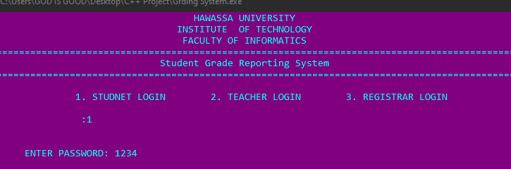

*Whenever the user choses one of these the program prompts the user to enter password. The passwords are: 1234 for student login 4321 for teacher login and 0102 for registrar login.*

* *If the user chooses Registar login and entered the correct password he\she will be presented with the registrar’s main menu.*

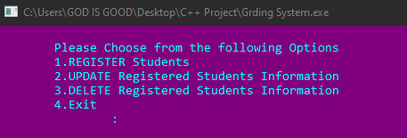

*This menu screen has the options to:*

1. *Add details of new student and save it permanently on file*
2. *Edits the records incase of any mistake while adding student data*
3. *To either remove the file or student details*
4. *Terminates the program*

* *In the case the registrar selects The Register Students option, they are prompted to choose department of of the student about to be registered.*

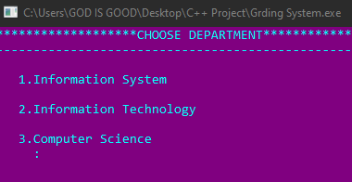

*Then user is taken to the department they chose and registers the details of the student as follows:*

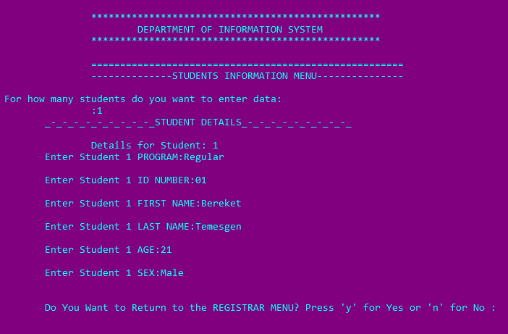

*The lastline navigates the user to the rigistrar’s main menu if typed ‘y’.*

* *If the update or delete options are selected in the first place the program would have looked like this:*

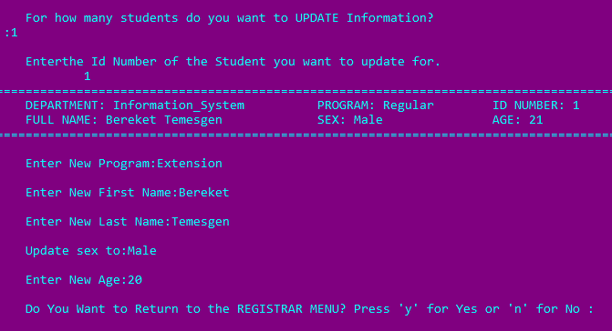

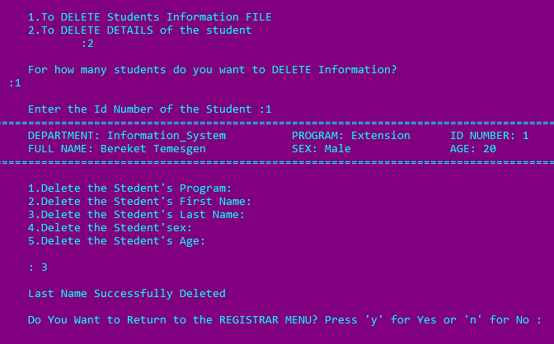

*That generally is how the students details is recorded, modified or removed by the registrar.*

* *If the Techer Login is Chosen:*

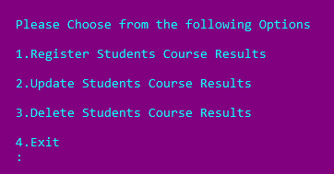

*Each of what these options perform is shown as follows in these Screenshots.*

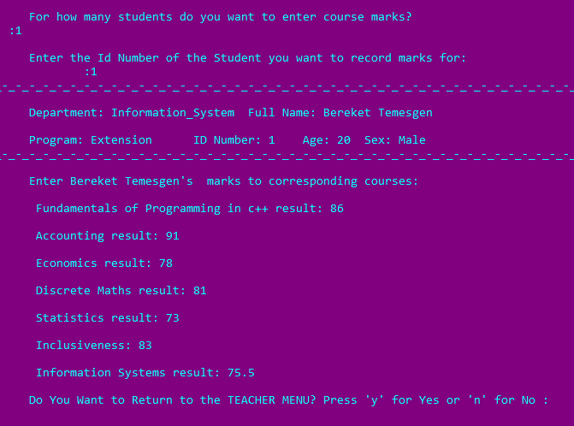

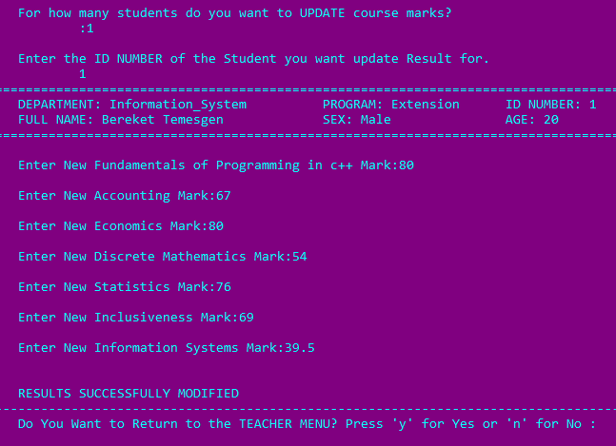

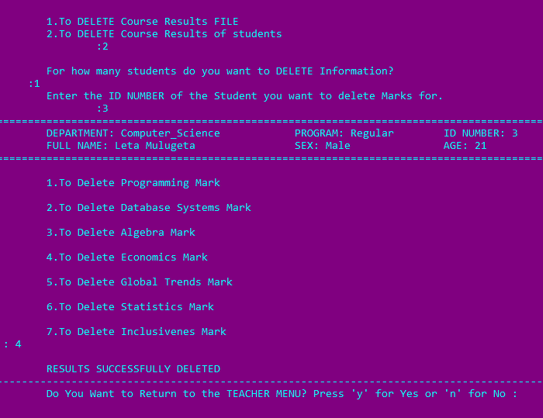

* *When logs in as student, he\she is only allowed to view grade report.*

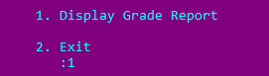

*The students grade report display all information registered under the entered ID Number and calculates the grade, total points and the GPA of the student.*

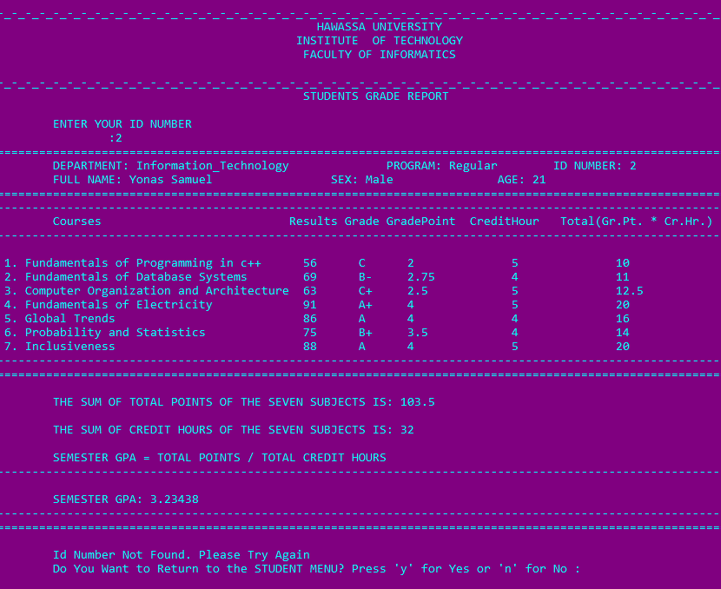

# Reference:

Chapter 5: File operations and Chapter 3. Structure, Unions, and Enumerations by Mokennen.k

<https://www.slideshare.net/vikrammahendra3/project-report-on-computer-shop-system-in-c>

<https://www.scribd.com/document/520359127/Project-Report-on-bank-management>

<https://www.codewithc.com/university-management-system-project-c/>

<https://sourcecodehero.com/college-management-system-project-in-c-with-source-code/>

<https://www.studocu.com/row/document/riphah-international-university/database/student-management-system-project-report/12309562>